Visual Art Activities

**St. Louis Public Schools**

**Continuous Learning Plans**

**PK- Grade 2 Visual Art ** Coloring in coloring books is also encouraged every week.\*\***

| WEEK 3 | Activities: “What do I do?”  *What needs to be done in order to learn the material?* | Resources: “What do I need to do it?”  *What print and electronic resources are available to support your learning? What materials are needed?* | Examples: “What does it look like?” |
| --- | --- | --- | --- |
|  | Create a paper mosaic portrait.   1. Draw a face large so it fills the page. 2. Cut up different colored construction paper into small pieces. 3. Place small dots of glue on the portrait. 4. Place the small pieces of construction paper on the dots of glue. Try to create patterns with the colors. | * Colored construction paper * Pencil * Scissors * Glue | Image result for paper mosaic portrait elementary |
| Draw a large picture using cool colors (Blue, green, and purple) and warm colors (red, orange, and yellow).  Use one group of colors in the foreground and one group of colors in the background. | * Blank white paper * Crayons, markers, or colored pencils |  |

**St. Louis Public Schools**

**Continuous Learning Plans**

**PK- Grade 2 Visual Art**

| WEEK 4 | Activities: “What do I do?”  *What needs to be done in order to learn the material?* | Resources: “What do I need to do it?”  *What print and electronic resources are available to support your learning? What materials are needed?* | Examples: “What does it look like?” |
| --- | --- | --- | --- |
|  | Create a paper sculpture showing a variety of lines (including vertical lines, horizontal lines, diagonal lines, zigzag lines, spiral lines, varied/expressive lines, and curved lines).   1. Cut out strips of construction paper to a variety of lengths. 2. Fold or bend the strips to form different types of line. 3. Glue one or both ends of the strips to on sheet of paper. (Strips can overlap, cross each other, and touch.) | * Construction paper * Scissors * Glue * Video: How to Create a Paper Line Sculpture <https://www.youtube.com/watch?v=Z2z1wQzDVzs> * See line examples page attached. | Image result for kindergarten paper line sculpture |
| Practice creating different patterns, using differ types of lines, colors, and shapes. In the provided landscape picture, fill each area with a different pattern.  For example: red, blue, red, blue, or | * Colored Pencil or Crayon * Worksheet attached |  |

**St. Louis Public Schools**

**Continuous Learning Plans**

**High School Visual Art**

| WEEK 5 | Activities: “What do I do?”  *What needs to be done in order to learn the material?* | Resources: “What do I need to do it?”  *What print and electronic resources are available to support your learning? What materials are needed?* | Examples: “What does it look like?” |
| --- | --- | --- | --- |
|  | 1. Trace your hand on a piece of paper in different positions (bunny ears, all fingers spread out, etc.) 2. Using crayons or markers, add details to the hand tracings to make them look like animals. (Add eyes, feet, tails, fur, etc.) | * Colored pencils, crayons, or markers * Blank paper * Video: 35 FUN AND EASY DRAWING TRICKS <https://www.youtube.com/watch?v=aZsgJg10SNk> | Image result for trace your hand animals |
| 1. Draw a large scene on the sidewalk with sidewalk chalk. 2. Lay down or sit down in the picture and pretend to be part of the scene. (For example: Draw an outer space scene, lay down on the sidewalk, pretend to fly through space.) 3. Have you parents take a photo of you in your drawing. | * Sidewalk chalk * Smart Phone or camera |  |

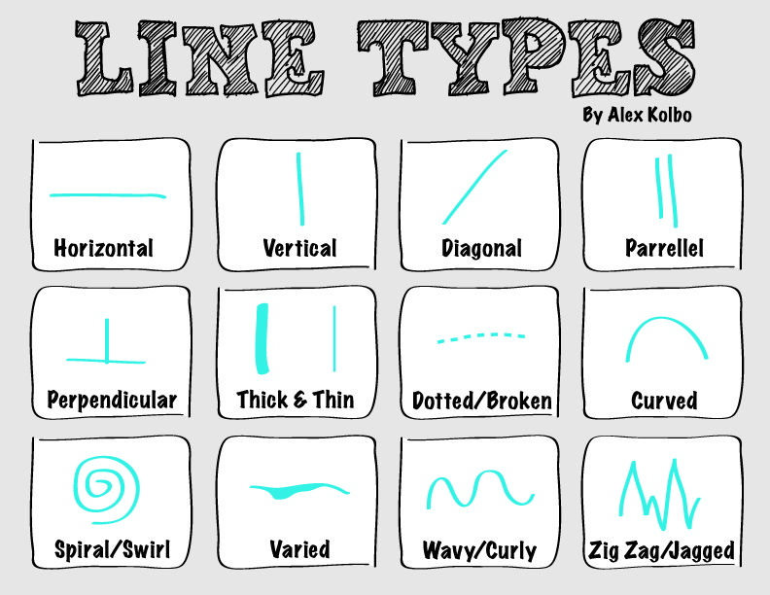

Using colored pencil, fill each area with a different pattern.

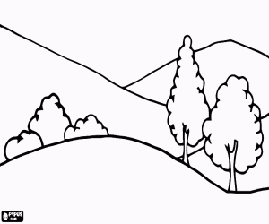

**Elements of Art**

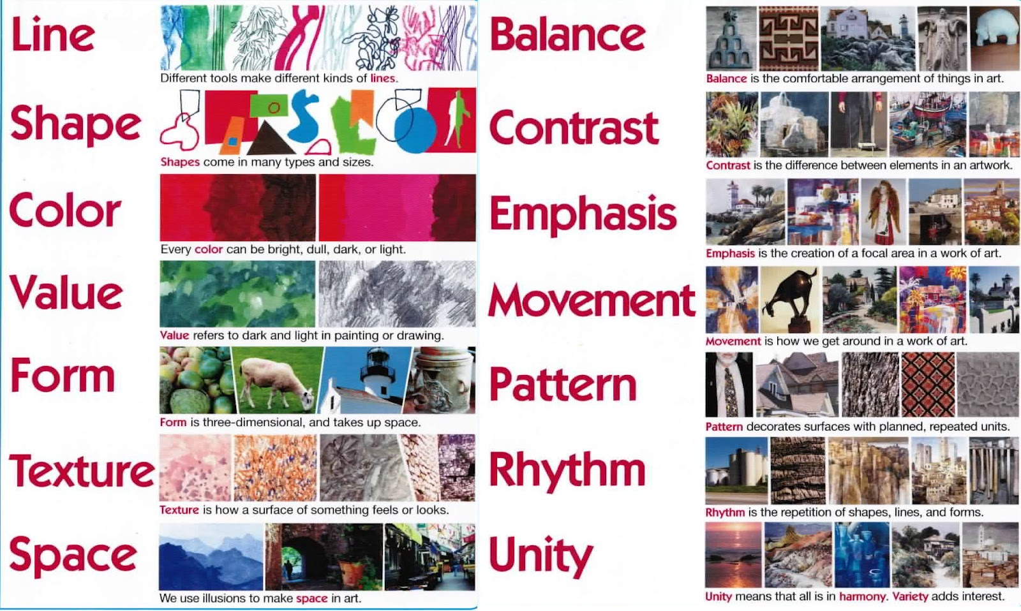

**Principles of Art**



**Coloring Pages**

